**Michael Smith**

**CSE 460**

**Homework 1**

**23 January 2018**

1. **How many processes does the following piece of code create? Why?**

**This code will create a total of 7 processes for the fork function, and a total of 8 when the main function is included. The main function calls the first fork which creates the first branch. Then main calls the second fork function and that creates a second branch. Lastly the main calls the third function creating a final branch which is finished after the third fork finishes. However; the first branch will call a second fork which then calls a third fork, and the first fork also calls a third fork. Making the first branch have four processes. Then the second branch, the second fork will call a third fork. Making the second branch have 2 processes.**

1. **Part a) Chaining processes**

**Chain.cpp**

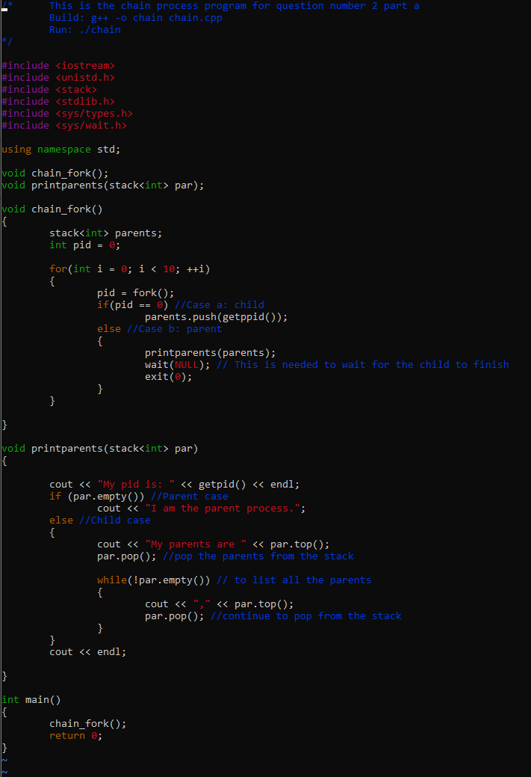

**Chain's Output**

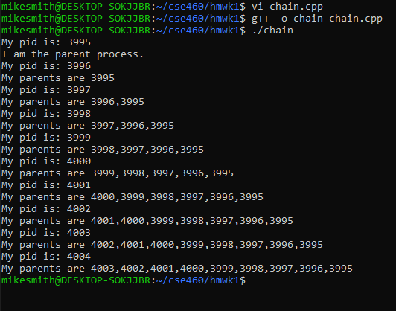

**Part B**

**Fanout.cpp**

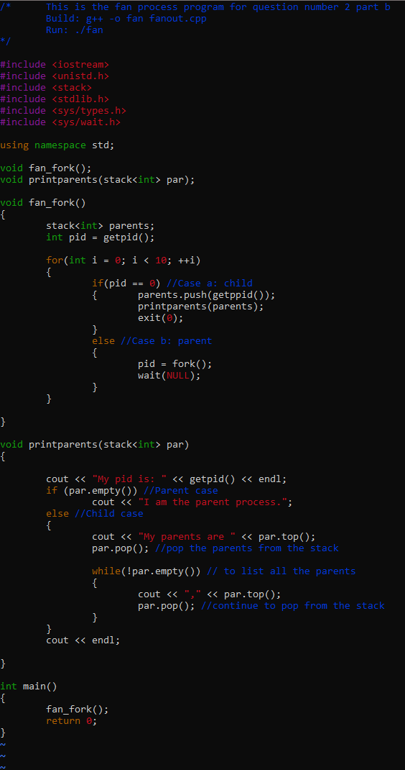

**Fanout Output**

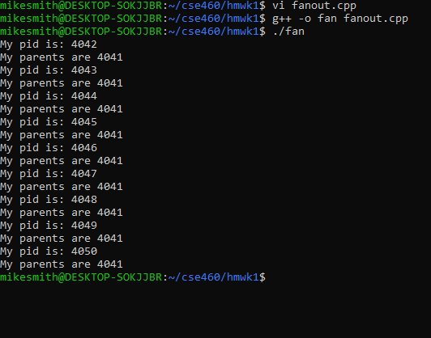

1. **Test1.cpp**

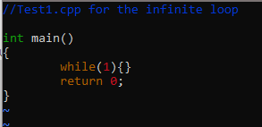

**KillTest Shell Script**

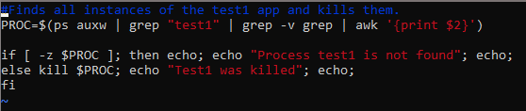

**KillTest Output**

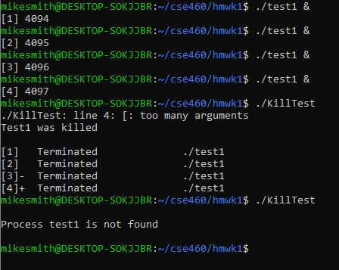

Score: 40/40 I achieved each part of the assignment with no errors. Also had captured perfect outputs for each of the steps of the assignments.